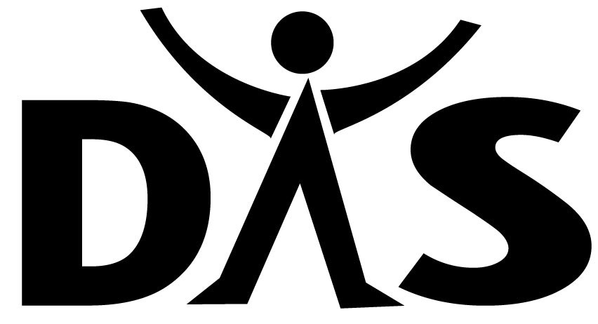
Satisfactory Academic Progress (SAP)
Standards for Clock Hour Modular Programs –

Clinical Medical Assistant
Dental Assistant
Massage Therapy
Medical Assistant and Phlebotomy
Medical Biller Coder
Pharmacy Technician

Effective 2020/2021 Academic Year and supersedes all previous policies.

The U.S. Department of Education requires all schools to establish and apply standards of Satisfactory Academic Progress (SAP) for eligible students to receive financial aid under the programs authorized by Title IV of the Higher Education Act (HEA). As with any area of Title IV, it is critical to understand that students must meet all SAP requirements within the context of all existing federal and institutional regulations. Thus, students must meet all Title IV and institutional requirements and regulations in order to be eligible to receive federal financial aid.

Satisfactory Academic Progress (SAP) is determined at the end of every payment period by the Financial Aid Office. Students are required to make Satisfactory Academic Progress toward the completion of an eligible vocational certificate.

DAS offers the following federal program: Pell Grant. This SAP standard covers this federal program.

The following are the Satisfactory Academic Progress (SAP) Standards, which students must meet to maintain financial aid eligibility in clock hour modular courses. Clock hour students will be measured on a payment period basis and use only coursework listed in the specific program of study.

SAP Evaluation Items

Cumulative Grade Point Average (Qualitative Measure)
A student demonstrates progression through modules within their specific program with a letter grade.

Student who fails a module (earns a grade of ‘NC’)
- If student earns 1st failing grade in the module, he/she will be placed in Warning Status for the subsequent payment period.
  - Student will be placed back into good standing upon successfully completing the previously failed module.
- If student fails more than one module, he/she will be dismissed and dropped from the program. Students can only fail one module.
GRADING SYSTEM –
Downey Adult School uses the following scale as its standard grading system.
GRADE PERCENT | GRADE | DESCRIPTION
90-100 | A | Excellent
80-89 | B | Good
75-79 | C | Satisfactory
0-74 | F | Fail
 | NC | No Credit
 | W | Withdrawal

NO CREDIT GRADE
A grade of “NC” is assigned when hours or course work are not completed by the student. This “NC”grade and hours are not counted in the student’s total clock hours.

WITHDRAWAL POLICY
Students who withdraw from the program will receive a grade of “Dropped” in each module they were enrolled in at the time of withdrawal.

Cumulative Pace of Completion (Quantitative Measure)
A student must complete 100% of the total number of hours scheduled for each payment period (Attempted hours divided by scheduled hours). For this calculation, there is no rounding.
Program  Name | Clock Hours/Weeks | Payment Period II  *Check Point  (clock hours) | Maximum  Timeframe
Dental Assistant | 800 hours  40 weeks | 400 | 1200 hours  60 weeks
Massage  Therapy | 600 hours  32 or 38 weeks | 300 | 900 hours  48 or 57 weeks
Clinical Medical Assistant | 660 hours  20, 32 or 38 weeks | 330 | 990 hours  39, 48, or 57 weeks
Medical Assistant and Phlebotomy | 700 hours  38 weeks | 350 | 1050 hours  57 weeks
Medical Biller Coder | 660 hours  26, 30 or 38 weeks | 330 | 990 hours  39, 45 or 57 weeks
Pharmacy Technician | 620 hours  32 or 38 weeks | 310 | 930 hours  48 or 57 weeks

Maximum Timeframe
Student attending a clock hour program will be limited to 150% of the hours required to complete the student's program of study. The total number of hours may include the total program hours and any hours taken if a student is repeating any coursework within the same enrollment.
If a student is unable to complete a certificate program within the 150% timeframe calculation, the student is ineligible for financial aid as the student is not capable of completing the requirements within the regulatory guidelines.

Satisfactory Academic Progress (SAP) Standards - Statuses
Satisfactory Academic Progress is determined at the end of each payment period (scheduled clock hours). All payment periods at Downey Adult School are included when determining a student's satisfactory academic progress.
There are defined outcomes once SAP has been determined at the end of each payment period (each program may have different payment periods), below is an example of a payment period:
If the school states an academic year for a clock hour student is 900 hours (26 weeks). The principles below would be followed:
- Programs lasting less than one year (900 hours) in length would be split into 2 equal payment periods.
    - Example: Program is 660 hours (32 weeks) in length
      - Each payment period would be 330 hours (16 weeks)
Satisfactory Academic Progress Standards for clock hour students (and financial aid purposes) will be each payment period using defined grades.
Financial Aid Good Standing Status
Student has met all the requirements of satisfactory academic progress and will continue to be eligible for federal financial aid grants, as long as all other financial aid requirements are met.
Financial Aid Warning Status
Student did not meet all the requirements of satisfactory academic progress and are now placed on "Warning.” Students will receive financial aid if they are on "Warning" status as long as all other financial aid requirements are met.
Students have the length of their current program in which they have been placed on "Warning" to meet all of the conditions of satisfactory academic progress or they will be dismissed from the program.
Students must meet all of the SAP standards to be considered to be in good satisfactory academic standing. The school issues a formal warning payment period to students at the end of the first payment period during which they fail to meet one or more of the SAP standards. Students who have not met all of the SAP standards are ineligible for Title IV aid at the end of the warning payment period.
Students who meet all of the SAP standards during their payment period of warning are returned to good satisfactory academic standing for financial aid.
A student may not have more than one failed module.

Financial Aid Dismissal
Students who are not meeting cumulative SAP standards and are no longer eligible for warning status will be dismissed from the program. Students on financial aid that are dismissed are not eligible for Title IV aid. DAS does not offer an appeal process.

